Step 1: Product Backlog

List of Features – User requirements

* Create a GUI
* Retrieve news source
* Compile music library
* Connection between music and similar words
* Give music recommendation
* Set “Related Score” (varying value on )

Extra Features

* Specify sections of news

1 SP = 1 Hour

|  |  |  |
| --- | --- | --- |
| Product Backlog Item | Story Points | Priority Points |
| A user wants an interface to interact with | 9 | 9 |
| A user wants music recommendations to listen to based off news | 6 | 9 |
| A user requires a music library for the application to work | 4 | 9 |
|  |  |  |

Sprint Backlog – Technical Aspect (Breaking what the User wants into tasks for the Engineer (Us))

|  |  |  |
| --- | --- | --- |
| Sprint Backlog Item | Story Points | Priority Points |
| Determine word recognition |  |  |
| Mood recognition |  |  |
| Connection between music and similar words |  |  |
| Set “Related Score” (varying value on ) |  |  |
| Allow the application to Retrieve news source |  |  |

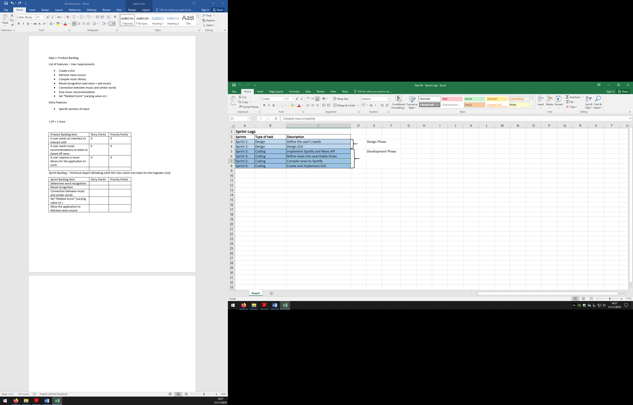

From the Sprint Logs above, we have split the logs between two phases; the design phase and development phase.

**Sprint 1**

From the sprint logs, sprint 1 is in the design phase of the Scrum project. In order to successfully create the application the first step needed was to identify the user’s needs. In doing this, we as able to understand what features were needed for the artefact, thus allowing us to start searching for the specific features of the artefact and to structure how the artefact is going to be created. Identifying the users needs is an extremely important part especially when using the scrum methodology in this project.

**Sprint 2**

Like Sprint 1, Sprint 2 is also part of the design phase. In this sprint, we had advanced to creating the specific GUI (Graphical User Interface) for the artefact. Creating the GUI was important for the Scrum Project as it started to give the project and team an idea in which way the artefact was going to be created. It was also important so show what features were going to be utilised the most from the GUI.

**Sprint 3**

Sprint 3 is a part of the development phase; this phase is where the project starts to develop the artefact. In this sprint, we just started to develop the artefact by implementing the relevant APIs which were the news API and Spotify API. Implementing the APIs were critical to the Artefact as the news API and Spotify API allowed such features like collecting the correct news and then compiling it into the Spotify playlists.